**VNM Motion System and FlyPT Mover Guide**

# 1. Download VNM UI

Download [VNM UI](https://vnmsimulation.com/download) and open it (add exception for VNM UI if computer detects virus). Click tab motion:

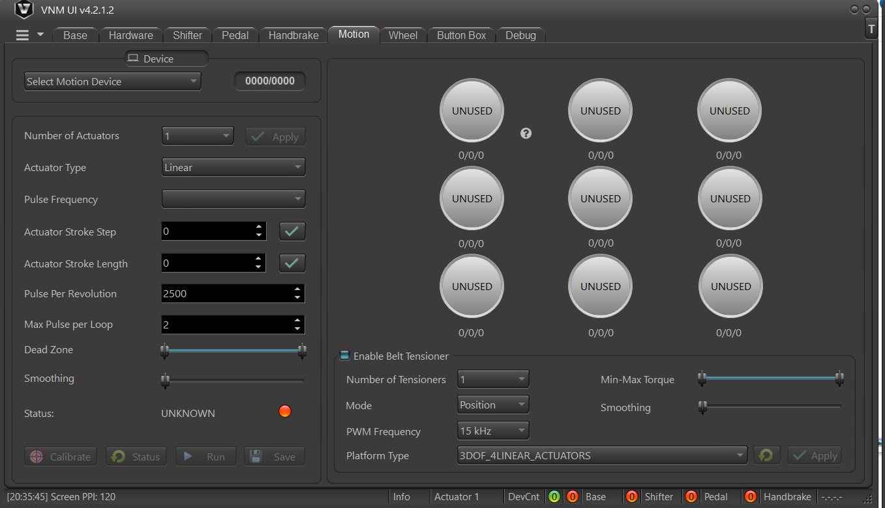

In Number of actuators: Choose exactly how many actuator in your motion system.

In Pulse Frequency: Choose whatever frequency as your liking. **We recommend you should try from 100-250 at the beginning.** After being familiar with motion system, you can choose higher frequency. The higher pulse frequency the higher speed of actuator.

Smoothing to make the motion system work smoother. The higher value, the higher smoothness.

Number pulse per loop is the number of pulses you want to send to actuator each 1ms. The higher value the faster of actuator’s speed.

Actuator stroke length: choose each actuator to config the length of stroke based on your system.

Other parameters should let it be as default of VNM Motion System.

# 2. Download FlyPT Mover and configuration

* Download [FlyPT Mover](https://www.flyptmover.com/).
* Download the configuration file of correct VNM Motion system at.

<https://vnmsimulation.com/download>

* Open FlyPT Mover, click right mount button, choose local file and open the configuration file that you have downloaded.

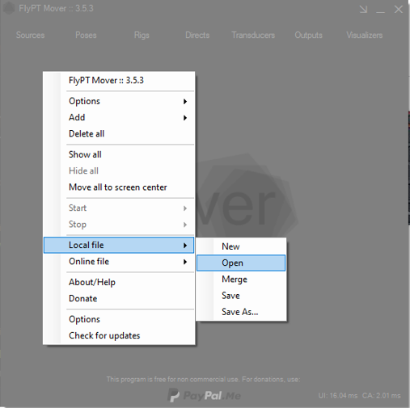

Note: Must choose correct configuration file for your motion system

Before connecting the motion controller to PC. The 1st you open Device Manager. Connect Motion controller to PC and you will see new port com appears in Device Manager -> Ports (COM&LPT).

In FlyPT Mover, choose Output-Serial, click update port 🡺 choose correct port and click connect. Now, all actuators will run to the middle positions.

# 3. Add game

In FlyPt Mover, click right mouse 🡪 Add 🡪 Source 🡪 choose which game you want. And now the source that you choose, displays on main window of FlyPT Mover, click on it and click connect. Now you can open game and race.

On each Poses, choose source is the game you want.

# 4. Enable telemetry

Some games already enable telemetry default like AC, ACC, iRacing, Project car, … But some games dont. You have to enable them.

## 4.1. ETS2/ATS2

Go to “FlyPT Mover 3.5.3\Files for sources” copy folder “bin\win_x64” to “path to ETS2/ATS2 game folder (for example: “D:\Steam Games\steamapps\common\Euro Truck Simulator 2\bin\win_x64\plugins”) If don’t have plugins create it.

## 4.2. F1 game

Open F1 game 🡪 Game Option 🡪 Settings 🡪 Telemetry Settings🡪 Change UDP Telemetry from OFF to ON, UDP Port is same as UDP port of FlyPT Mover configured (20777 as example).

Choose format can be F1 2019/2020 (must be same with game you add in FlyPT Mover)

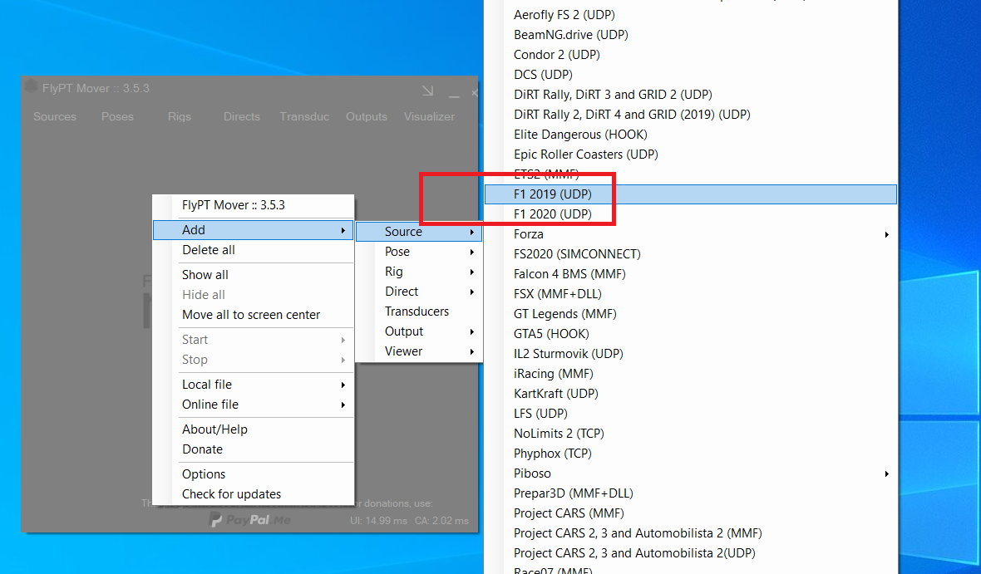

## 4.3. Forza Horizon

* **Game Forza Horizon 4**: Same as F1 game, check Request to port to use to config in Froza Horizon. 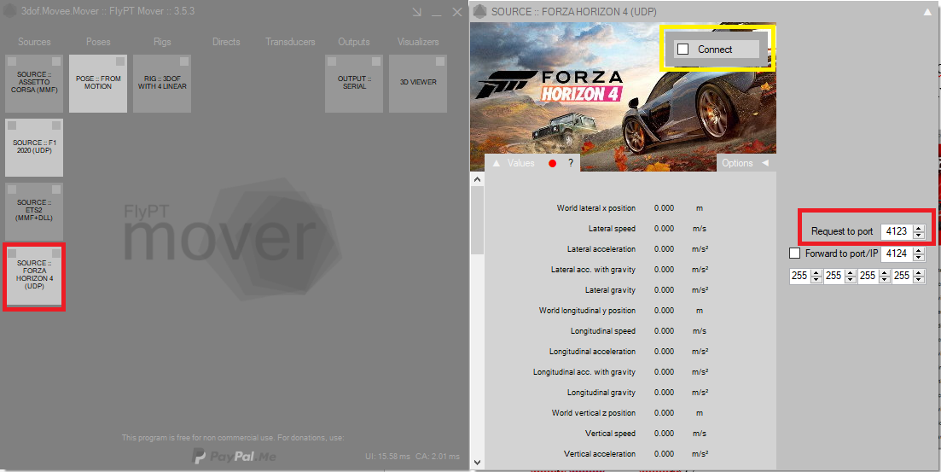

Open game 🡪 HUD AND GAMEPLAY 🡪set DATA OUT IP ADDRESS “127.0.0.1”, DATA OUT IP PORT is 4123.

## 4.4. Dirt Rally 2, Dirt Rally 4

* Open by note pad or notepad plus plus "C:\Users\[username]\Documents\MyGames\DiRTRally2.0\hardwaresettings\hardware_settings_config.xml"
* Find **<udp enable = "false" extradata = "0" ip="127.0.0.1" port="20777" delay="1" />**
* Change to **<udp enable = "true" extradata = "0" ip="127.0.0.1" port="20777" delay="1" />**

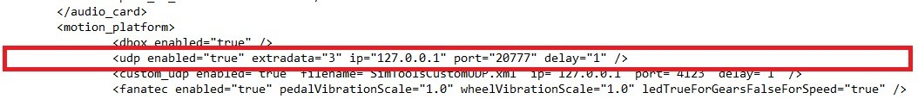

* Save file
* Open game and race

Note: After choosing game, in source window, the yellow color shows that already got the data from game. And you have to choose exact source in Poses.

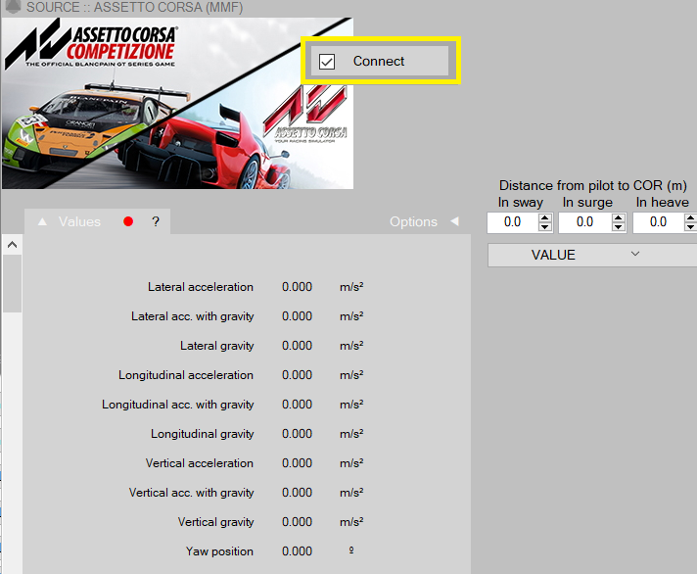

Other game will update later.